Joel Aldrich Matteson
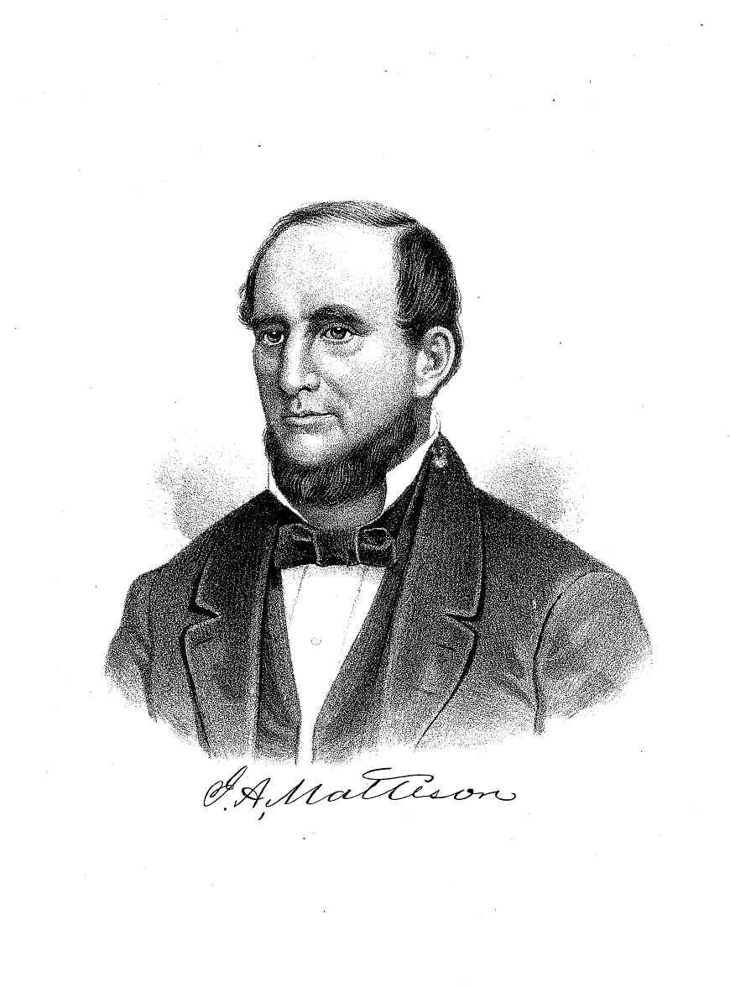
Joel A. Matteson (MAT-tĕh-son) – Governor 1853 – 1856 – was born August 8, 1808, in Jefferson County, New York, to which place his father had removed three years before. His father was a farmer in fair circumstances, but a common English education was all that his only son received. Young Joel first tempted fortune as a small tradesman in Prescott, Canada, before he was of age. He removed from that place to his home, entered an academy, taught school, visited the principal Eastern cities, improved farm his father had given him, made a tour in the South, worked there in building railroads, experienced a storm on the Gulf of Mexico, visited the gold diggings of Northern Georgia, and returned via Nashville to St. Louis and through Illinois to his father’s home, when he married. In 1833, having sold his farm, he removed, with his wife and one child, to Illinois, and entered a claim on Government land near the head of the Aux Sable River, in what is now Kendall County. At that time there were not more than two neighbors within a range of ten miles of his place, and only three or four houses between him and Chicago. He opened a large farm. His family was boarded 12 miles away while he erected a home on his claim, sleeping, during the time, under a rude pole shed. Here his life was once placed in imminent peril by a huge prairie rattlesnake sharing his bed.

In 1835, he bought largely at government land sales. During the speculative real-estate mania which broke out in Chicago in 1836 and spread over the State, he sold his lands under the inflation of that period and removed to Joliet, where he became a heavy contractor on the Illinois & Michigan Canal. Upon the completion of that job in 1841, when hard times prevailed, business at a stand, contracts paid in State script; when all public works except the canal were abandoned, the State offered for sale 700 tons of railroad iron, which was purchased by Mr. Matteson at a bargain. This he accepted, shipped and sold in Detroit, realizing a very handsome profit, enough to pay off all his canal debts and leave him with a surplus of several thousand dollars. His enterprise next prompted him to start a woolen mill at Joliet, in which he prospered, and which, after successive enlargements, became an enormous establishment.

In 1842, he was first elected a State Senator, but, by a bungling apportionment, John Pearson, a Senator holding over, was found to be in the same district, and decided to represent it. Matteson’s seat was declared vacant. Pearson, with nobleness difficult to appreciate in this day of greed for office, unwilling to represent his district under the circumstances, immediately resigned his unexpired term of two years. A bill was passed in a few hours, ordering a new election, and in ten days’ time Mr. Matteson was returned re-elected and took his seat as Senator. From his well-known capacity as a businessman, he was made Chairman of the Committee on Finance, a position he held during this half and two succeeding Senatorial terms, discharging the important duties with ability and faithfulness. Besides his extensive woolen-mill interest, when work was resumed on the canal under the new loan of $1,600,000 he again became a heavy contractor, and also subsequently operated largely in building railroads. Thus he showed himself a most energetic and thorough businessman.

He was nominated for Governor by the Democratic State Convention which met at Springfield April 20, 1862. Other candidates before the Convention were D. L. Gregg and F. C. Sherman, of Cook; John Dement, of Lee; Thomas L. Harris, of Menard; Lewis W. Ross, of Fulton; and D. P. Bush, of Pike. Gustavus Koerner, of St. Clair, was nominated for Lieutenant Governor. For the dame offices, the Whigs nominated Edwin B. Webb and Dexter A. Knowlton. Mr. Matteson received 80,645 votes at the election, while Mr. Webb received 64,408. Matteson’s forte was not on the stump; he had not cultivated the art of oily flattery, or the faculty of being all things to all men. His intellectual qualities took rather the direction of efficient executive ability. His turn consisted not so much in the adroit management of party, or the powerful advocacy of great governmental principles, as in those more solid and enduring operations which cause the physical development and advancement of a State – of commerce and business enterprise, into which he labored with success to lead the people. As a politician he was just and liberal in his views, and both in official and private life he then stood untainted and free from blemish. As a man, in active benevolence, social virtues and all the amiable qualities of neighbor or citizen, he had few superiors. His messages present a perspicuous array of facts as to the condition of the State, and are often couched in forcible and elegant diction.
The greatest excitement during his term of office was the repeal of the Missouri Compromise, by Congress, under the leadership of Stephen A. Douglas in 1854, when the bill was passed organizing the Territory of Kansas and Nebraska. A large portion of the Whig Party of the North, through their bitter opposition to the Democratic Party, naturally drifted into the doctrine of anti-slavery, and thus led to what was temporarily called the “Anti-Nebraska” party, while followers of Douglas were known as “Nebraska or Douglas Democrats.” It was during this embryo stage of the Republican Party that Abraham Lincoln was brought forward as the “Anti-Nebraska” candidate for the United States Senatorship, while Gen. James Shields, the incumbent, was re-nominated by the Democrats. But after a few balloting in the Legislature (1855), these men were dropped, and Lyman Trumbull, an Anti-Nebraska Democrat, was brought up by the former, and Mr. Matteson, then Governor, by the latter. On the 11th ballot Mr. Trumbull obtained one majority, and was accordingly declared elected. Before Governor Matteson’s term expired, the Republicans were fully organized as a national party, and in 1856 put into the field a full national and State ticket, carrying the State, but not the nation.

The legislature of 1855 passed two very important measures – the present free-school system and a submission of the Maine liquor law to a vote of the people. The latter was defeated by a small majority of the people.

During the four years of Gov. Matteson’s administration the taxable wealth of the State was about trebled, from $137,818,079 to $349, 951,272; the public debt was reduced from $17,398,985 to $12,843,144; taxation was at the same time reduced, and the State resumed paying interest on its debt in New York as fast as it fell due; railroads were increased in their mileage from something less than 400 to about 3,000; and the population of Chicago was nearly doubled, and its commerce more than quadrupled.

Before closing this account, we regret that we have to say that Mr. Matteson, in all other respects an upright man and a good Governor, was implicated in a false re-issue of redeemed canal script, amounting to $224,182.66. By a suit in the Sangamon Circuit Court the State recovered the principal and all the interest excepting $27,500.

He died in the winter of 1872-3, at Chicago.¹

Secret societies are probably coeval with man’s existence in organized society, and perhaps will continue to exist until the last syllable of recorded time. We know that the causes which actuate them are beneficial and good, because the results achieved are so grand and glorious. Freemasonry bears an early date in Joliet. From records preserved by W. W. Stevens, Esq., and furnished us for perusal, we find that a lodge was organized as early as 1840, under a dispensation from the Grand Lodge of Kentucky, before Illinois had a Grand Lodge of her own. The dispensation was signed by Most Worshipful Abner Cunningham, Grand Master of Kentucky, and Right Worshipful Philip Swigert, Grand Secretary, dated November, 1840, and issued to Juliet Lodge, U. D., Juliet, Illinois. Right Worshipful C. Jackson, proxy of the Grand Master of Kentucky, came all the way from that Grand Jurisdiction to institute this Lodge, and set the brethren to work upon the square. It continued under dispensation until 1842, when it was chartered by the same august body, as Juliet Lodge #10. The first officers under the charter were Jacob Patrick, Master; Norman Hawley, Senior Warden; Aaron Kinney, Junior Warden; Robert G. Cook, Treasurer; Maurice Murphy, Secretary; Thomas J. Wade, Senior Deacon; Fenner Aldrich, Junior Deacon; Thomas J. Kinney, Tiler; with twenty-seven original members, besides the officers. Among them will be recognized the names of many of the leading citizens of the day, viz: Jared Runyon, Thomas Williams, David L. Gregg, Joel A. Matteson, James Brodie, Henry G. Brown, Ethan Wetherbee and Benjamin Richardson, all of whom, with three exceptions, joined the first year. This was the first Masonic Lodge in Will County, and from the number, appears to be the tenth in the State. It continued to work under its charter until 1845, when some dissensions having arisen in the Lodge, and the Grand Lodge of Illinois in the meantime having been organized, the latter Grand Body annulled the charter of Juliet Lodge, No. 10, and afterward issued a dispensation to establish Mt. Joliet Lodge. In due time, it was chartered as Mt. Joliet Lodge, No. 42, by Most Worshipful Nelson D. Morse, Grand Master of Illinois, and under which name and number it still exists. (Note: Mt. Joliet Lodge #42 has, since this writing, merged with Matteson Lodge #175 by consolidation.) The first officers of the new Lodge were Wm. C. Little, Master; Myron K. Bronson, Senior Warden; and Joel George, Junior Warden. For years, the first Lodge (Juliet, No. 10) had no regular place of meeting, but kept their paraphernalia in a chest, and met on the "highest hills, or in the lowest vales," metaphorically speaking, but usually in the old stone block on the West Side. The present officers of Mt. Joliet Lodge are John Gray, Master; P. B. Ryan, Senior Warden; J. G. Patterson, Junior Warden; and John S. Millar, Secretary, with 160 members on the roll. Matteson Lodge was organized under dispensation in 1865, by Most Worshipful James L. Anderson, Grand Master of Illinois. In October, 1856, it was chartered as Matteson Lodge, No. 175, and named for ex-Gov. Matteson, one of the influential Masons and enterprising business men of the town. The first officers were: William Smith, Master; Nelson B. Elwood, Senior Warden; James T. McDougall, Junior Warden; Abijah Cagwin, Treasurer; John McGinnis, Jr., Secretary; Benjamin Richardson, Senior Deacon; W. S. Brooks, Junior Deacon, and C. II. Swayne, Tiler. The following are the present officers: W. G. Wilcox, Master: J. C. Lang, Senior Warden; George C. Raynor, Junior Warden; and J. L. Raynor, Secretary; with about one hundred and fifty names upon the roll of membership.²

Sources:
1 – Portrait and Biographical Album of Whiteside County, IL;
Chicago: M. A. Leeson & Co., 1887, pages 147 – 148.
2 – The History of Will County, IL;
Chicago: Wm. LeBaron, Jr., 1878, pages 408-409.

